Extra activity 2
- Activity : Perform a Monte Carlo Simulation using Google Colab.
This activity requires you to work on the Python Notebook that was discussed in Week 0 Part 2 content.
- Open the Python Notebook shared with you in the supplementary content
- Make a copy this file into your drive (You are free to organize the python notebook within your drive)
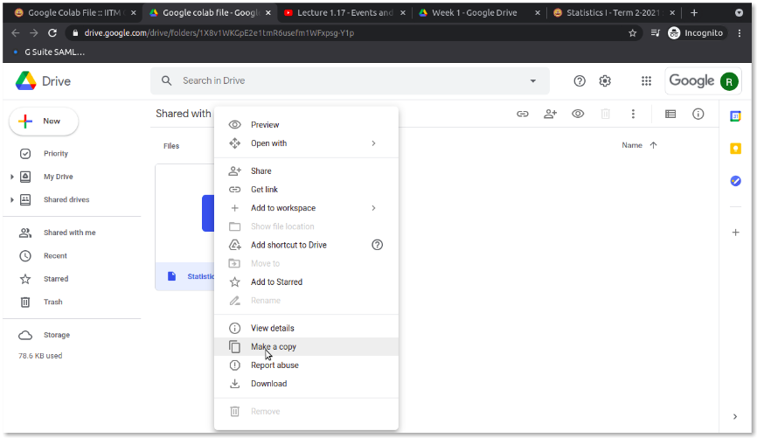
- Open the file using Google Colab
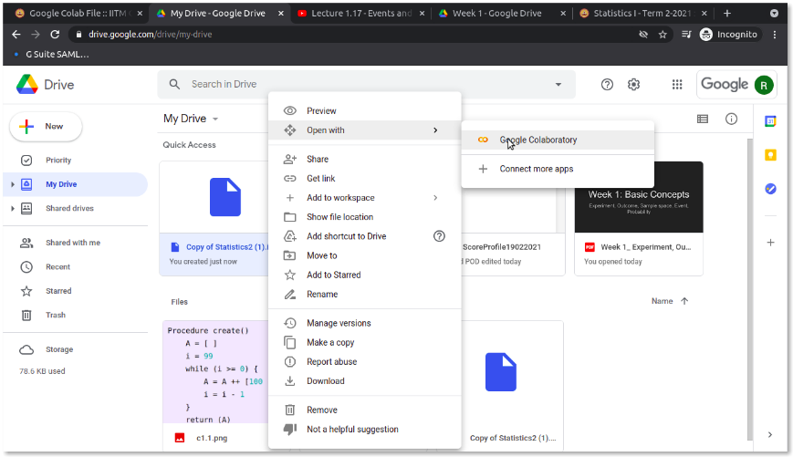
- Go through the code in Google Colab (and also refer to last video of Week 0 Part 2) to understand how the parameters can be manipulated in Python Notebook.
- Select an experiment and event from various examples seen so far in the lectures (or any other problem that interests you).
- Add the selected experiment and event to the notebook and perform a Monte Carlo simulation to verify the computed probability.
- Add the Google Colab notebook to the site (Make sure that sharing permission is view for everyone in Onlinedegree domain) under the heading ‘Activity 2’
- Take a screenshot of the website with the embedded Colab Notebook and add the screenshot under the heading `Activity-2'.

